Signature Cocktails

Little Pink Box 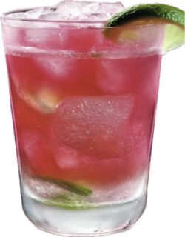

Coconut Rum
Peach Schnapps
Pineapple Juice
Cranberry Juice
Splash of Soda
Garnish of lime

Pink 75 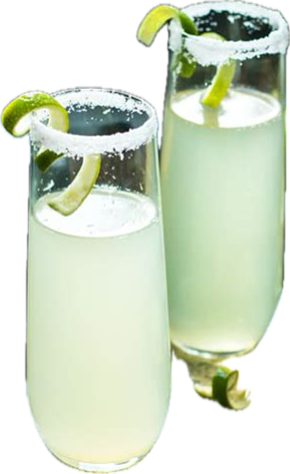

Tequila
Champagne
Lime juice
Garnish of lime
Pink Box Spicy Margarita 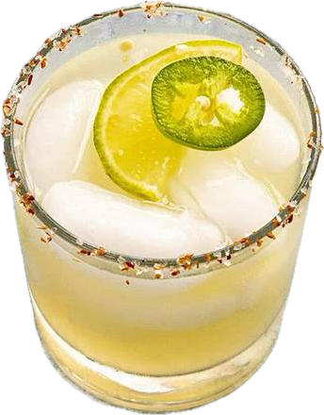

Tequila
Cointreau
Lime juice
Tajin Rim
Garnish of Jalapeno and Lime

